ICES Datras Report 2006

Report of the Workshop on Implementation in DATRAS of Confidence Limits Estimation of
10-12 May 2006
ICES Headquaters, Copenhagen
DRAFT

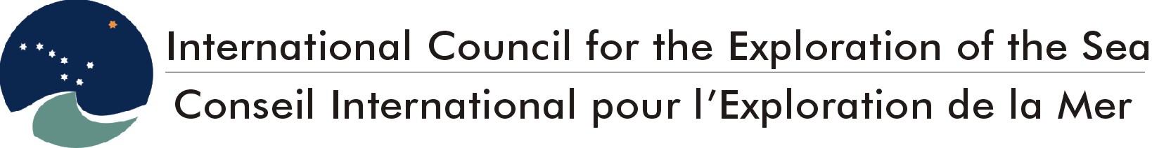
International Council for the Exploration of the Sea
Conseil International pour l’Exploration de la Mer
H.C. Andersens Boulevard 44-46
DK-1553 Copenhagen V
Denmark
Telephone (+45) 33 38 67 00
Telefax (+45) 33 93 42 15
www.ices.dk
info@ices.dk

Recommended format for purposes of citation:
ICES. 2026. Report of the Workshop on Implementation in DATRAS of Confidence Limits Estimation of, 10-12 May 2006, ICES Headquaters, Copenhagen. . 39 pp.
For permission to reproduce material from this publication, please apply to the General Secretary.
The document is a report of an Expert Group under the auspices of the International Council for the Exploration of the Sea and does not necessarily represent the views of the Council.
© 2026 International Council for the Exploration of the Sea.
Contents

1 Introduction 2
2 Description of surveys stored in DATRAS 3
2.1 Survey design 3
2.1.1 BITS 5
2.1.2 NS-IBTS 6
2.1.3 BTS 8
2.1.4 EVHOE 9
2.1.5 Scottish Groundfish Survey 12
2.2 Data stored 13
3 Description of indices calculation 14
3.1 BITS 15
3.2 NS-IBTS indices calculation 16
3.3 BTS indices 17
3.4 EVHOE 17
3.4.1 Computation of global abundance indices 17
3.4.2 Computation of abundance indices at age 17
3.5 Scottish Western IBTS 19
4 Description of estimation of the accuracy of the abundance estimator 20
4.1 Using the variance as uncertainty estimator 20
4.2 Geo statistics 20
4.3 Bootstrap 21
4.4 Discussion of possible approaches 21
4.5 Conclusions 23
5 The algorithm that should be implemented into DATRAS 24
5.1 Length distribution bootstrapping 25
5.2 ALK; Bootstrap age distribution by length class 26
5.3 Number of bootstraps 27
5.4 The index calculations. 27
5.5 Presentation of results. 28
6 Possible tests of the magnitude of the problem of using stratification different from that used in the index calculation for the North Sea IBTS and BTS. 28
7 References 28
Annex 1: Participants 30
Annex 2: 31

Introduction
Basic data from several ICES coordinated trawl and beam trawl surveys in the Baltic Sea, the North Sea, the area west of Scotland and France are stored in ICES’ DATabase of TRAwl Surveys, DATRAS, in the ICES Secretariat (Figure 1). Every year and for each survey, member countries report data, and indices of fish stock abundance are calculated and fed into the routine fish stock assessment work.
Estimates of uncertainties of these indices are not developed, although these probably would be very useful for the population modelling used in the assessment work.
Uncertainty estimates of the abundance indices would also be very useful for evaluating individual surveys, e.g. to determine whether they could be intensified to improve the precision of the fish stock assessment models.
The EU commission has therefore requested ICES to implement uncertainty estimatation in DATRAS with the goal to be able to supplement the routine abundance indices with uncertainty estimates. ICES shall also provide the EU Commission with an evaluation of the historic performance of the surveys, based on uncertainty estimates of historic data.
The terms “variance estimation” and “uncertainty of the abundance estimator” are used loosely. In the context of DATRAS, these terms refer to the confidence interval, i.e., the interval where we have, x% falling below and x% falling above. There are therefore two decisions to be made:
- Decision on the percentage (x) corresponding to the tail of the distribution of the abundance index estimator;
- Decision on the procedure to calculate the distribution
Obviously, the first decision is arbitrary but it is required for consistency between years and between surveys. Therefore, herein, focus is on the second question: how to calculate the distribution. This report analyses statistical methods and their implementation.

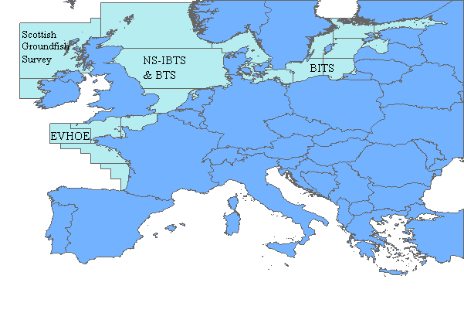
Figure 1. Surveys in ICES area for which data are stored in DATRAS

Description of surveys stored in DATRAS

Survey design
The survey design influences how to estimate the variance of the indices, e.g., whether a survey is random or fixed design. Table 1 shows an overview of all the surveys in DATRAS listed by country since the design varies among countries, even within a given ICES coordinated survey. The term “semi-random” for surveys in which stations are selected based on a list of clear haul positions.
The table includes surveys other than those for which data are currently loaded in DATRAS. Data from all the listed surveys are expected to be provided during 2006, but will not be included in the analyses made in 2006. However, ICES should be able to provide uncertainty estimates for these surveys when data are checked and loaded into DATRAS.
The table is followed by a more detailed description of the survey design of the surveys which, at present, are stored in DATRAS.
Table 1. Survey design for surveys stored or expected to be stored in DATRAS in 2006.

Country/Survey | North Sea IBTS  Stratified by Stat. Rec. | EVHOE  Stratified by depth | Irish IBTS  Stratified by stat. Rec. | Dutch BTS  Stratified by stat. Rec. | Spanish Gulf of Cadiz  Stratified by depth | Spanish Porcupine  Survey  Stratified by depth | North Spanish Coast surveys  Stratified by depth | Portuguese Bottom trawl Survey  Stratified by depth | BITS  Stratified by depth | Scottish western IBTS  Stratified by Stat. Rec.
Sweden | fixed design in Q1 Sk and Kat and random in Q3 Sk |  |  |  |  |  |  |  | Random
Denmark | Semi-random |  |  |  |  |  |  |  | Random
Norway | Fixed
Netherlands | Semi- random |  |  | Semi- random
Germany | Semi-Random |  |  |  |  |  |  |  | Random
England | Fixed
Scotland | Semi-Random/Fixed |  |  |  |  |  |  |  |  | Semi-Random/Fixed
Ireland |  |  | Random
Spain |  |  |  |  | Random | Random | Random
Portugal |  |  |  |  |  |  |  | Fixed
France | Semi-Random | Random
Latvia |  |  |  |  |  |  |  |  | Random
Estonia |  |  |  |  |  |  |  |  | Random
Poland |  |  |  |  |  |  |  |  | Random
Russia |  |  |  |  |  |  |  |  | Random

BITS
Baltic cod stock has been monitored annually in first quarter since 1982, and in fourth quarter since 1991; and both bottom trawl surveys are carried out by most countries surrounding the Baltic (Figure 2). The national research vessels have each surveyed part of the area with some overlap in coverage and applied a depth stratified sampling design. However, different gears and design were applied and, in 1985, ICES established a Study Group on Young Fish Surveys in the Baltic in order to standardize the surveys. After agreement, a common standard trawl gear and survey design were implemented in 2001, resulting in the coverage of the whole Baltic Sea.
The BITS is conducted as a depth-stratified survey. The strata are based on sub-divisions and 20 m depth layers. Each year, the total number of planned stations is allocated to the subdivisions and the depth layers according to agreed procedure. Then before the international trawl surveys start, the necessary stations of the depth layers are randomly selected from a list of clear haul data. These stations are a sub-sample of the possible trawl tracks. If the number of possible tracks is not large enough for a random selection in some strata, fixed stations can be used. However, this situation only occurs in shallow waters in subdivision 28.
The following table summarizes the number of planned stations by subdivision and depth layer for the BITS in spring 2006. In most cases, the numbers of planned stations are more than 7. Only in SD 23 and SD 27, are the numbers of planned stations less than 5 due to various reasons.
Subdivision | 22 | 23 | 24 | 25 | 26 | 27 | 28
Depth layer
10 - 40 | 23 | 3 | 21 | 20 | 9 | 3 | 11
41 - 60 |  |  | 14 | 28 | 9 | 2 | 8
61 - 80 |  |  | 11 | 27 | 17 | 2 | 15
81 - 100 |  |  |  | 12 | 16 | 3 | 12
100 - 120 |  |  |  |  | 10
Total | 23 | 3 | 46 | 87 | 61 | 10 | 46
In some parts of the area and in some years, the oxygen level is too low for cod and therefore the catch will be zero. These low-oxygen areas are located in the deepest basins of the eastern Baltic Sea with variable intensity. When it is shown, based on at least two stations, that oxygen deficiency occurs and the catch is zero in this depth layer, oxygen deficiency can be documented by realizing only the hydrographical measurements and it is not necessary to realize the planned haul, but zero catch must be added to DATRAS. These hauls are marked by the validity code N.
Length of all individuals of the main target species cod and flounder are measured. It is allowed to measure the length of sub samples for species like herring and sprat when the total catch is high. In this case, the length distribution is raised up with the total catch in number.
The CPUE values (catch per hour) are corrected in units of the large standard gear TVL using conversion factors. Sub sample are taken from the different hauls for analysing age, sex, weight and maturity. The individuals for estimating the ALK are sampled from different hauls according to the requirement of the BITS manual. The table below gives the minimum number of otoliths from each length group, which must be cut per country, survey, ICES Subdivision and species based on the length distribution.

Length-class | Minimum number of age readings
With probably only one age group (age group 0, 1) | 2 to 5
With probably more than on age group
Portion of the length class less than 5% | 10
Portion of the length class more than 5% | 20

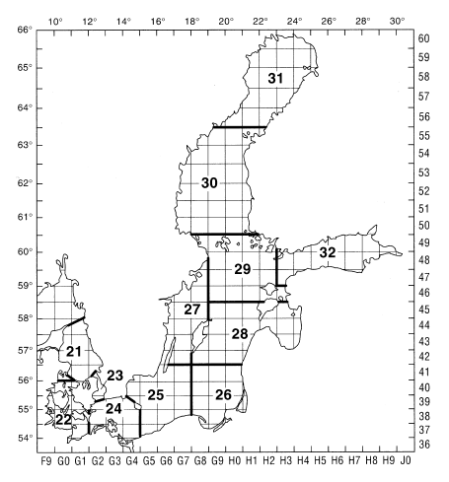
Figure 2. Map of ICES Subdivisions and ICES statistical squares within the Baltic Sea area covered by BITS and IBTS (Kattegat).

NS-IBTS
In the North Sea, the IBTS started in the 1960s as a survey that was directed at juvenile herring and was at that time called the International Young Herring Survey (IYHS).
As it was gradually realised that the survey also yielded valuable information for other fish species, such as cod and haddock, the objectives were broadened and the survey was renamed into the International Young Fish Survey (IYFS). Besides the IYFS, which was carried out in the first quarter, a number of national surveys developed in the 1970s and 1980s that were mainly carried out in the third quarter.
In 1990, ICES decided to combine the international and the national surveys into the IBTS. The IBTS has been carried out twice per year (1st and 3rd quarter) since 1997, and on a quarterly basis in the period 1991-1996.
The stratification of the survey grid has always been based on ICES statistical rectangles (one degree longitude x 0.5 degree latitude ~ 30 x 30 nautical miles). Each rectangle is usually fished by the ships of two different countries, so that at least two hauls are made per rectangle. The ICES-rectangles are used to evenly distribute the hauls over the whole North Sea (Figure 3).
Most statistical rectangles contain a number of possible tows that are deemed to be free of obstructions, and vessels are free to choose any of these positions in the rectangles that they are surveying. In some rectangles, sampling may be further stratified due to significant changes in seabed depth which may, in turn, cause variations in the fish population.
In rectangles or strata that are to be sampled more than once by the same vessel, is the IBTS manual recommends that valid hauls are separated by at least one day or by at least 10 miles wherever possible. Tows in adjacent rectangles should also be separated by at least 10 miles.
In practise, all countries except England (Q3) and Norway (Q1 and Q3) select the hauling position randomly from a list of clear haul positions. England and Norway use the same fixed hauls every year.
To obtain the length distribution, the catch is sorted into species or species/sex. Where the numbers of individuals are too large for all to be measured (due to time constraints etc), a representative sub-sample is selected of at least 75 fish (although sampling a very limited length range could be adequately achieved with less). In the event that a truly representative sub-sample cannot be selected, it will be necessary to further sort the species into two or more size grades or categories (Manual for the International Bottom Trawl Surveys, version VII).
Otolith samples are collected within 9 specified Roundfish areas as illustrated in figure 3. For all species, the same areas are used. For the target species, the following minimum sampling levels are tried to be obtained for each sampling area:
herring: 8 otoliths per 1/2 cm group
sprat: 16 otoliths per 1/2 cm group 8.0-11.0cm
12 otoliths per 1/2 cm group >11.0cm
mackerel: 8 otoliths per 1 cm group
cod: 8 otoliths per 1 cm group
haddock: 8 otoliths per 1 cm group
whiting: 8 otoliths per 1 cm group
Norway pout: 8 otoliths per 1 cm group
saithe: 8 otoliths per 1 cm group

For the smallest size groups, that presumably contain only one age group, the number of otoliths per length class can be reduced. Inversely, more otoliths per length are required for the larger length classes.
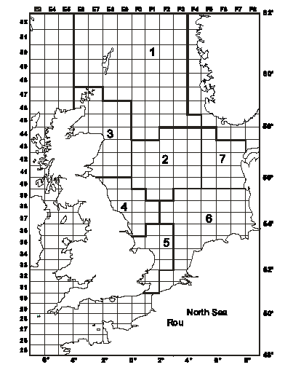
Figure 3. IBTS survey area with statistical rectangles and roundfish areas used for stratification of age-length keys

BTS
The Netherlands BTS was initiated in 1985 to estimate the abundance of the dominant age groups of plaice and sole including pre-recruits. Initially the survey was only carried out in the south-eastern North Sea (ICES area IV) using RV "Isis" equipped with a pair of 8 m beam trawls.

The survey was designed to take between one and three hauls per ICES rectangle. The stations are allocated over the fishable area of the rectangle on a "pseudo-random" basis to ensure that there is a reasonable spread within each rectangle. No attempt is made to return to the same tow positions each year.
In 1995, the survey was expanded into the central and northern part of the North Sea using RV "Tridens". Sampling strategy is similar, but only one haul per rectangle is taken, preferably close to the centre of the rectangle (figure 4).

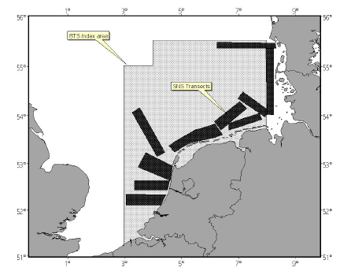
Figure 4. Locations of the BTS Index area and SNS transects in the North Sea. In this report only BTS is relevant.

EVHOE
For the 1987 to 1996 period, the Survey EVHOE was conducted in the Bay of Biscay on an annual basis with the exception of 1993 and 1996. It was conducted in the third or fourth quarter except in 1991, when it took place in May. In 1988, two survey were conducted: one in May the other in October.
The Celtic Sea was surveyed from 1990 to 1994, but the sampling was restricted to a small geographical area. The duration is between 40 to 45 days depending on year and availability of ship. Since 1997, the survey has covered all the Celtic Sea and Bay of Biscay during the 4th quarter.
Since 1997, the main objectives have been:
- construction of time series of abundance indices for all the commercial species in the Bay of Biscay and the Celtic Sea with an emphasis on the yearly assessed species where abundance indices at age are computed.
- to describe the spatial distribution of the species and to study their inter-annual variations.
- to estimate and/or update biological parameters (growth, sexual maturity, sex ratio...)
The stratification scheme adopted defines 6 depth strata within a geographic stratification that separates the Bay of Biscay in 2 areas and the Celtic Sea in 3 areas (figure 5).
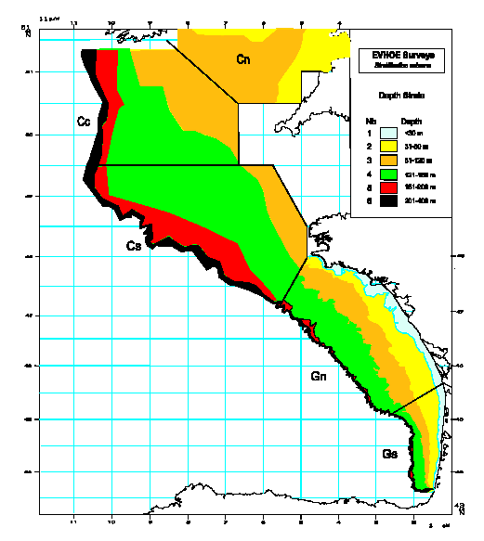
Figure 5. Area covered and stratification used in the EVHOE surveys.
The sampling strategy is a stratified random allocation: the number of sets per stratum optimised by a Neyman allocation on numbers variance averaged on the 4 most important commercial species (hake, monkfishes and megrim) leaving at least two stations per stratum. 140 sets are planned every year. This number of sets is adjusted according to the time at sea available.
The catch is sorted by species, counted and weighted. In the case of a huge catch of one dominant species, only a fraction of the catch is sorted.
Biological parameters (length, weight, status of maturity among others) and hard structures (otoliths and illicia) are collected. The specification of the sampling level of otoliths and illicia is described in table 2 (Manual for the International Bottom Trawl Surveys in the Western and Southern Areas, version 2).
Table 2. Specification of the sampling level of otoliths and illicia by country. 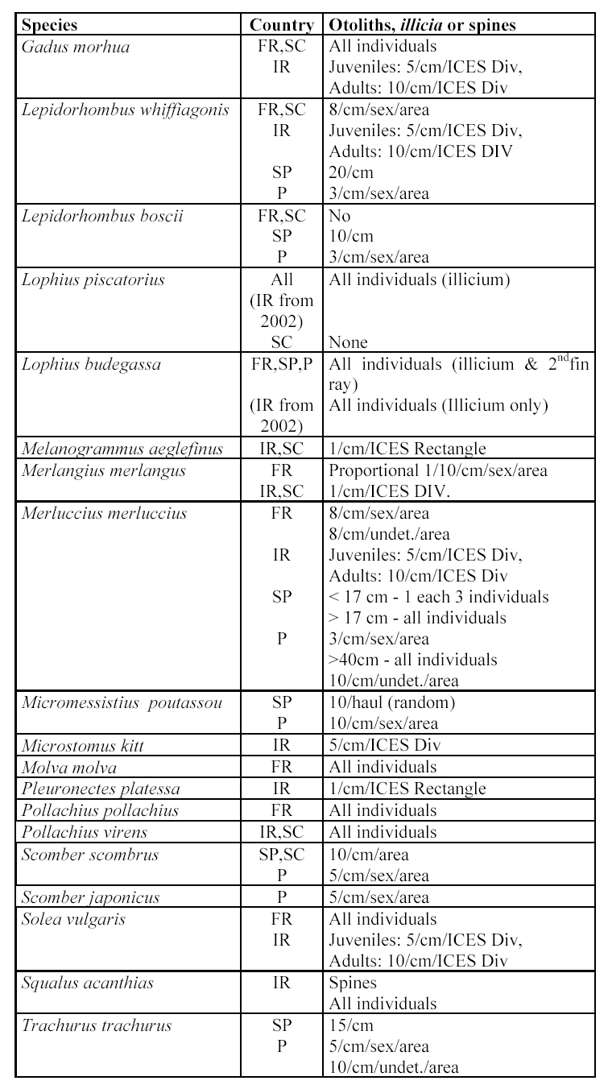

Scottish Groundfish Survey
The Quarter 1 (March) Scottish Groundfish survey started in 1981, and was initially intended to cover the fishing grounds on the continental shelf to the west of Scotland. In 1996, the survey area was extended to include the northern Irish Sea (Figure 6).
The survey covers Division VIa and extends into the northern part of the Irish Sea and NW of Ireland. The depth range covered has been 20 to 500m since 2000. The target species are cod, haddock, whiting, saithe and herring and age frequencies are constructed for these species. All other fish species encountered are also sampled for at least length frequencies.
Indices of abundance at age are calculated for all the target species and these data are used at the Northern Shelf Assessment Working Group and also made available for the Herring Assessment Working Group.
The Scottish Mackerel recruit Quarter 4 survey began in 1990, and has a depth range of 20 - 500m. The survey extended to the area west of the British Isles between 56 and 61 N, and bounded by the 200m depth-contour and the coast. Initially the survey area did not include the area of the Minch and the north channel of the Irish Sea, but gradually the spatial coverage altered so that now it mimics the Quarter 1 survey.
The target species have now been extended to include cod, haddock, whiting, saithe and herring as well as the original target species mackerel.
The Scottish West Coast Surveys use a ICES rectangle based sampling strategy similar to that used in the North Sea. Trawl stations are selected at one tow per rectangle based on a library of clear tows. There is no explicit return to the same trawling position every year, although this is generally the case.
Since 1999, the potential for using a depth rather than rectangle based stratification has been under investigation. To this end, and where possible, those rectangles which display substantial internal depth variation have been sampled twice at different depths. The recent inclusion of samples collected between 200 and 500m would suggest that depth stratification should be initiated as soon as possible.
The sampling scheme for length and age distribution is described under the EVHOE survey.
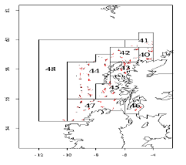
Figure 6. Scottish demersal sampling areas

Data stored
As part of the DATRAS project, surveys conducted in the ICES area of relevance to DATRAS were identified. Table 3 shows which countries collect trawl survey data and which submit the data to DATRAS. Spain, Portugal and Ireland will start submitting their data to ICES in 2006.
Table 3. Gear and area combinations against the countries that conduct the surveys. S indicates the country participates in the survey, D indicates the data are in the database.
Country | Bottom trawl |  |  |  | Beam trawl
 | Baltic | North Sea | Western Areas  (Scottish Groundfish  Surveys) | Southern  Areas  (EVHOE) | North Sea
Belgium |  |  |  |  | S
Denmark | S,D | S,D
England |  | S,D | S |  | S
Estonia | S,D
Finland | S,D
France |  | S,D | S,D | S,D
Germany | S,D | S,D |  |  | S
Ireland |  |  | S
Latvia | S,D
Lithuania | S,D
Netherlands |  | S,D |  |  | S,D
Norway |  | S,D
Poland | S,D
Portugal |  |  |  | S
Russia | S,D
Scotland |  | S,D | S,D
Spain |  |  | S | S
Sweden | S,D | S,D

Table 4 shows the year range of data that are stored in DATRAS for the various surveys. Some of the surveys started as country-performed survey and were later standardised into a common international coordinated survey with e.g. one type of gear. It will therefore only make sense to make a survey performing analysis on the years where the survey have been standardised into one common survey with one gear type. The year ranges in which this has been the case can be seen in Table 3.
Table 4. Year ranges of data in DATRAS and to be used in a variance analysis.
Survey | Quarter | Year range in DATRAS database | Year range to use for analysis
Scottish Groundfish Survey | 1 | 1985-2006 | 1985-2006
 | 4 | 1990-2005 | 1990-2005
BITS | 1 | 1991-2006 | 2001-2006
 | 4 | 1991-2005 | 2001-2005
BTS | 3 | 1985-2004 | 2003-2004  ICES hope to get more ALK data.
EVHOE | 4 | 1998-2003 | 1998-2003
NS-IBTS | 1 | 1965-2006 | 1983-2006
 | 2 | 1991-1997 | 1991-1997
 | 3 | 1991-2005 | 1991-2005
 | 4 | 1991-1997 | 1991-1997

Description of indices calculation
All surveys described in this report and for which data are expected to become part of DATRAS deliver fishery-independent data (i.e. indices) to be used for the tuning of stock assessments of one or more commercial species. Table 5 gives an overview of the different species, where they are caught and which working groups use their indices.
Table 5: Overview of the species for which the surveys provide indices
Survey | Area | Species | Assessment WG
BTS | North Sea, Celtic  Sea and Irish Sea | plaice | northern shelf WG (VIIa), southern shelf (VIIe, VIIe, VIIg,f), and North Sea and Skagerrak WG
BTS | North Sea, Celtic  Sea and Irish Sea | sole | northern shelf WG (VIIa), southern shelf (VIIe, VIIe, VIIg,f), and North Sea and Skagerrak WG
IBTS Q1 | North Sea and Skagerrak | cod | North Sea and Skagerrak WG
IBTS Q1 | North Sea and Skagerrak | whiting | North Sea and Skagerrak WG (Usually but not in 2001)
IBTS Q1 | North Sea and Skagerrak | saithe
IBTS Q1 | North Sea and Skagerrak | haddock | North Sea and Skagerrak WG
IBTS Q1 | North Sea and Skagerrak | Norway pout | North Sea and Skagerrak WG
IBTS Q1 | North Sea and Skagerrak | herring | Herring Assessment south of 56 WG
IBTS Q1 | North Sea and Skagerrak | sprat | Herring Assessment south of 56 WG
IBTS Q1 | North Sea and Skagerrak | mackerel | Mackerel and Horse Mackerel Assessment WG (Made available–not used but deemed important for distribution etc)
IBTS Q3 | North Sea and Skagerrak | Cod | North Sea and Skagerrak WG (Scottish & English separately)
IBTS Q3 | North Sea and Skagerrak | Whiting | North Sea and Skagerrak WG (Usually but not in 2001)
IBTS Q3 | North Sea and Skagerrak | Haddock | North Sea and Skagerrak WG (English data only)
IBTS Q3 | North Sea and Skagerrak | Norway pout | North Sea and Skagerrak WG (Scottish & English separately)
Scottish grundfish survey Q1 | VIa | Cod | Northern Shelf WG
Scottish grundfish survey Q1 | VIa | Haddock | Northern Shelf WG
Scottish grundfish survey Q1 | VIa | Whiting | Northern Shelf WG
Scottish grundfish survey Q1 | VIa | Monkfish | Northern Shelf WG (Exploratory data analysis)
Scottish grundfish survey Q1 | VIa | Mackerel | Mackerel and Horse Mackerel Assessment WG (Made available–not used but deemed important for distribution etc)
Scottish grundfish survey Q4 | VIa | Mackerel | Mackerel and Horse Mackerel Assessment WG (Made available–not used but deemed important for distribution etc)
EVHOE | VII | Whiting | WG on assessment of Southern Shelf demersal stock
 |  | Cod | WG on assessment of Southern Shelf demersal stock
 |  | Hake | WG on assessment of Southern stocks of hake, monk and megrim
 |  | Monkfish | WG on assessment of Southern stocks of hake, monk and megrim
 |  | Anglerfish | WG on assessment of Southern stocks of hake, monk and megrim
 |  | Megrim | WG on assessment of Southern stocks of hake, monk and megrim
BITS | Baltic Sea | cod | Baltic WG

For all the surveys, there is one standard routine in DATRAS to allocate the ALK key to the length based CPUE data.
The CPUE per age (a), length and haul (H) is calculated as the fraction of the age distribution:
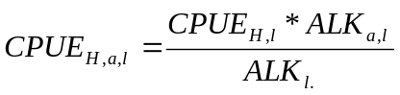
There are three possibilities for obtaining age information for a length class if an age distribution is missing for that length class:
- If length is less than the min length predefined in DATRAS, the age is set to age 1 in first quarter and 0 in all other quarters.
- If length is between min length and max length (also predefined in DATRAS), then age is set to the nearest ALK either at a length class before or at a length class after the one which misses an ALK. If there is one below and one after the length class at equal distance in length, a mean is taken.
- If the length is larger than max length, the age is set to the plus group.
After the age distribution is allocated to the length distribution, the age based indices are calculated. The indices are calculated differently for each survey. Below, the calculation for each survey is described.

BITS
In the BITS survey, indices are calculated for cod and flounder. There are two cod indices: one for the eastern Baltic, sub-divisions 25+26+28, and one for the western Baltic, sub-divisions 22+24. At present, only indices for the eastern cod are calculated by DATRAS.
CPUE for cod at length per haul from before 2001 is standardised to the standard TV3 trawl used by all vessels since 2001 by multiplying with a conversion factor (ISDBITS. 2001). Then the mean age at length per depth stratum and sub-division are calculated and weighted with the surface area (m²) of the stratum. From these means, the mean catch at age per sub-division and then the mean catch per index area are calculated.
For flounder, the index is only calculated for sub-division 25, and no conversion factor is applied to data before 2001. Otherwise the calculation is identical to the cod calculation.
Calculations:
- CPUE per length (l) and haul (H) are multiplied with the conversion factor (conf) for the gear to give CPUE adjusted for gear performances (conf)
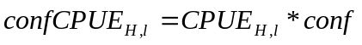
- Age is allocated to the length distribution as described above.
- Number per length (l) (1 cm group) per haul is summed by year, quarter, sub-division and depth stratum (DS) and divided with total hauls in the depth stratum.
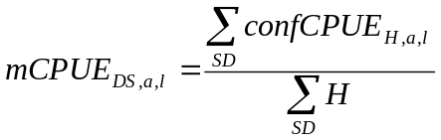
- Depth stratum ‘0-19’ is deselected
- Mean CPUE per length and stratum is multiplied by the area of the depth stratum (km²)
- The multiplied values are summed over depth stratum and index area (IA)
- The summed values are divided with sum of all stratum areas
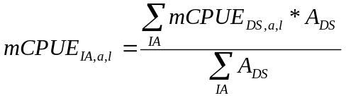
- The final indices by age are calculated by taking the sum of the length classes for the given age within the index area:
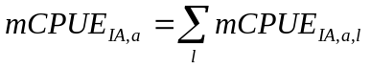

NS-IBTS indices calculation
In IBTS North Sea, the indices are calculated per index area, which are specific for each species. The indices are calculated as mean at age per statistical rectangle and then as a mean of the statistical rectangles over the index area. Some statistical rectangles are reduced in size due to land or very shallow water. For herring, sprat and saithe, the mean CPUE at age are weighted with the percent covered with water depths between 10m and 200m for these statistical rectangles.
- Number per length (l) and age (a) (1 cm group and semi cm for herring and sprat) per haul is summed by year, quarter, statistical rectangle (ST) and divided with total hauls in the statistical rectangle.
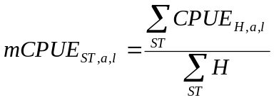
- Mean number by index area, sum of mean CPUE in all fished rectangles in index area (IA) divided by number of fished rectangles in index area:
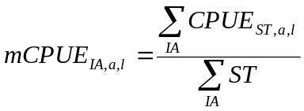
- The final indices by age are calculated by taking the sum of the length classes for a given age within the index area:

BTS indices
The BTS survey consists of many surveys not totally integrated and in different areas. Indices are therefore calculated separately for each survey/area combination.
In DATRAS, only the Dutch BTS survey is stored so far and, as ALK data are still missing, the indices are not calculated yet in DATRAS. When the indices are implemented they will be calculated the same way as the IBTS indices except that they will be standardised by half an hour haul and not by one hour.

EVHOE
Calculating the EVHOE survey indices is not yet implemented in DATRAS; however, this will be done in connection with developing the variance estimations. The following section is taken from the EVHOE manual and describe both how indices and variance should be calculated.

Computation of global abundance indices
The construction of raw abundance indices in Total Weight and number per set (stratified mean 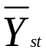 and its variance 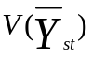) are computed following the stratified random sampling formulas as described by Pennington and Grosslein (1978):
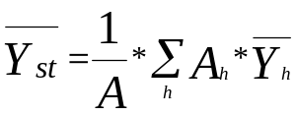
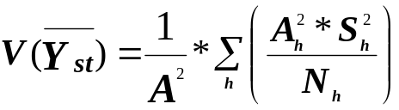
where :
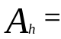 area of the 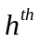 stratum
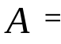 the total area
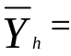 sample mean catch per tow in the stratum
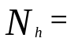 number of tows in the stratum
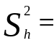 sample variance in the stratum

Computation of abundance indices at age
a. First phase, computation of average numbers at length and associated variances.
Estimation of average numbers at length j for a group of h strata (stratified mean 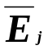) and its variance 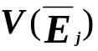) is computed according to the random sampling strategy already described for computation of global indices:

For each length class j :
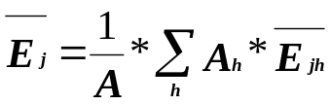 (1)
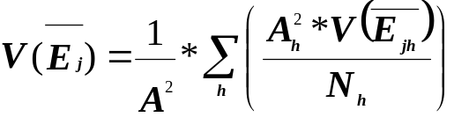 (2)
where :
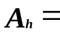 area of stratum h
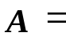 total area of the group of strata st
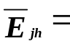 mean number per haul in length j for stratum h
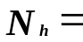 number of hauls in stratum h
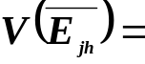 variance of the mean number in length class j for stratum h
b. Second phase, building the age-length key, computation of the proportions at age i per length class j and associated variances.
For each length class j the proportion of age i and its variance is computed :
(3)
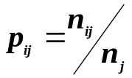
(4)
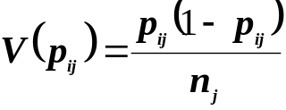
where :

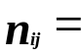 number of otoliths of age i in the length class j

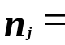 total number of otolith in the length class j

c. Third phase, computation of mean numbers at age and the associated variances.

The mean numbers at age are given by :
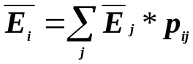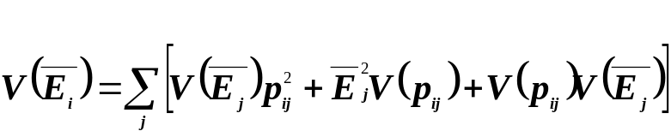The associated variance :
(5)

These computations all three phases are done by sex and the total age composition is given for each age i by:
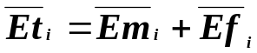
Its variance:
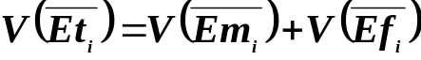
(6)
The sampling being independent on sex the covariance is not considered.

Scottish Western IBTS
The indices for the Scottish Western IBTS are calculated slightly differently from the indices in other surveys in DATRAS. Whereas all the other surveys are weighted by either area size or number of strata, the Scottish indices are weighted with the number of hauls samples in each sampling area.
- For each age, length and sub-area, sum across valid hauls and standardise to per 10 hours [Are they assuming each haul is one hour? If not should number of hours fished be included in the division?]

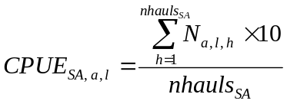
- Take a weighted sum over areas
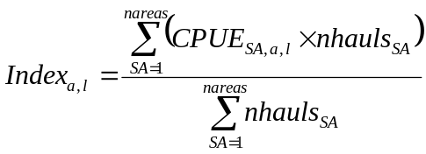

- Sum across length classes

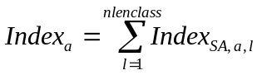

Description of estimation of the accuracy of the abundance estimator
The term variance estimation and uncertainty of the abundance estimator is used loosely above. In DATRAS, we are after the confidence interval, i.e. the interval where we have, say, 5% of falling below and 5% probability of being above.

Using the variance as uncertainty estimator
This calculation of the 2nd order moment (variance) is widely used and is well known outside technical statisticians. Methods for calculating this estimator are developed for virtually all survey designs, but differ among designs, i.e. there would be a separate algorithm for each survey; known estimators include fixed station surveys. Even where there is no analytical solution for the variance estimator to the maximum likelihood estimation, this can be done numerically in a routine fashion. It is easy to implement and can run as a routine procedure.
Calculation of confidence limits would be of the type (2 is chosen for simplification of the formula)
The approach is not robust to distributions that are far from symmetrical around the abundance estimator and therefore often a transformation is used, the classical example being the logarithmic transformation.
Reflection of the survey design could be through a multiplicative model or similar
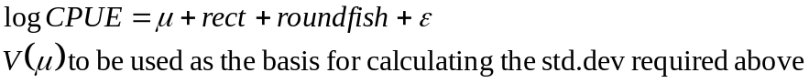
This could be implemented by linking DATRAS to R.

Geo statistics
Geostatistics is an expansion of the model described above which accounts for the geographical variance structure. The functional form of the variogram (variance as a function of distance between the stations) shall reflect the distribution of the species surveyed and is unlikely to be the same for each species. The functional structure of the variance would need stability between years for a routine implementation as the approach is not robust to changes in distribution between years; hence this approach may be difficult to implement on a routine basis. The analysis may involve transformation.
Geostatistics has many variants related to the underlying geographical structure of the population. A routine implementation would need to decide on one of these.
Provided the geostatistics model chosen is not too complicated, the fundamentals are easily understood can be explained to non-statisticians.
The calculation of confidence limits will be similar as described above.
An implementation might be to link DATRAS to an appropriate statistical package (e.g. R or SURFER).

Bootstrap
Bootstrapping overcomes the problems with asymmetric distributions and allows a direct estimation of the confidence limits.
Bootstrapping is based on the assumption that the samples available are indicative for the population distribution (similar assumptions as embedded under section 4.1). The bootstrap procedure shall reflect both the design and the assumption of the variance population structure on which the survey design is based.
Bootstrapping can be implemented as a routine, but must reflect the design, i.e. there would be a separate algorithm for each survey. Implementation would require special software to be written to reflect the survey design and assumption of stock distribution.

Discussion of possible approaches
We considered the technical advantages and disadvantages of a range of methods, including their suitability for implementation in DATRAS, making use of work reported in ICES WKSCFMD (2004), which reviewed analytical variance estimators, bootstrapping and modelling approaches and ICES WKSAD (2005), which considered the effect of spatial structure of the population and provides information on geo-statistical models. The summary table from WKSCFMD is reproduced at the end of this discussion.
The design-based approaches, bootstrapping and analytical calculations, scored well on issues relating to communication. Both have been widely used within fisheries, are relatively easy to explain, and do not have many assumptions. The lack of distributional assumptions also suggests they will be robust to changes in catch distribution.
Bootstrapping has technical advantages over analytical calculations because asymmetric distributions do not cause problems when calculating a confidence interval and covariance between ages is part of the output. A further issue with the usual analytical calculations is that they are based on the assumption of random (or stratified random) sampling, so they are not strictly valid for fixed stations designs.
The major concerns with bootstrapping are that strata with few observations can lead to poor estimates of variance and therefore a need to combine strata. Annex 2 provides tables with number of hauls per sample area and number of hauls in the suggested combined areas.
For age sampling, the survey protocols suggest there should be enough age samples per length group. We studied if this is true in two ways: by viewing a selection of ALK’s and for all surveys by calculating the proportion of length groups, above a relevant minimum length, in each ALK with only one age sample and with fewer than five age samples.
ALK from cod in BITS and NS-IBTS in first quarter 2006 is taken as an example in this report. It can been seen that, at least in NS-IBTS, a large proportion of the length classes are only represented by one sample (table 6) and only few length classes are represented with five or more samples (table 7). In some Roundfish areas, 100 percent of the length classes have been sampled less than five times.

Table 6. The table shows number of length classes where there have only been one age sample, the total number of length classes with samples, and the percentage of length classes with one sample of the total sample.
Survey | Year | Quarter | Species | Area | No of one sample | Total samples | Percentage of total samples
BITS | 2006 | 1 | Gadus morhua | 22 | 1 | 49 | 2
 |  |  |  | 24 | 1 | 49 | 2
 |  |  |  | 26 | 1 | 49 | 2
 |  |  |  | 28 | 2 | 43 | 4
NS-IBTS | 2006 | 1 | Gadus morhua | 1 | 8 | 27 | 29
 |  |  |  | 2 | 9 | 12 | 75
 |  |  |  | 3 | 8 | 23 | 34
 |  |  |  | 4 | 9 | 19 | 47
 |  |  |  | 6 | 11 | 14 | 78
 |  |  |  | 7 | 6 | 26 | 23
 |  |  |  | 9 | 1 | 49 | 2

Table 7. The table shows number of length classes where there have been less than five age samples, the total number of length classes with samples, and the percentage of length classes with one sample of the total sample.
Survey | Year | Quarter | Species | Area | No of less than five samples | Total samples | Percentage of total samples
BITS | 2006 | 1 | Gadus morhua | 22 | 9 | 49 | 18
 |  |  |  | 24 | 7 | 49 | 14
 |  |  |  | 25 | 1 | 49 | 2
 |  |  |  | 26 | 4 | 49 | 8
 |  |  |  | 28 | 8 | 43 | 18
NS-IBTS | 2006 | 1 | Gadus morhua | 1 | 21 | 27 | 77
 |  |  |  | 2 | 12 | 12 | 100
 |  |  |  | 3 | 15 | 23 | 65
 |  |  |  | 4 | 13 | 19 | 68
 |  |  |  | 6 | 14 | 14 | 100
 |  |  |  | 7 | 18 | 26 | 69
 |  |  |  | 9 | 17 | 49 | 34

Possible model-based approaches range from general linear models (GLMs) of survey cpue, to geo-statistical models which incorporate spatial structure, to more complex likelihood-based or Bayesian hierachical models. The GLM and geo-statistics approaches generally model indices which have already been calculated by age, while more complex models better represent the sampling process by including the variation due to sub-sampling age and estimating an age-length relationship. This ability to capture all the sources of uncertainty is particularly strong in Bayesian models.

Routine implementation was an issue for modelling approaches, particularly geo-statistical models. Geo-statistical models cannot be properly implemented on all surveys in DATRAS as several use randomised not systematic sampling schemes. Other modelling approaches would be more flexible but could require different model set-ups for different surveys and species. This could lead to debate over the appropriateness of a model for any particular survey, and could make explaining the approach to non-scientists more difficult. Expert knowledge would be needed to run modelling approaches as the model fit and assumptions need to be checked.
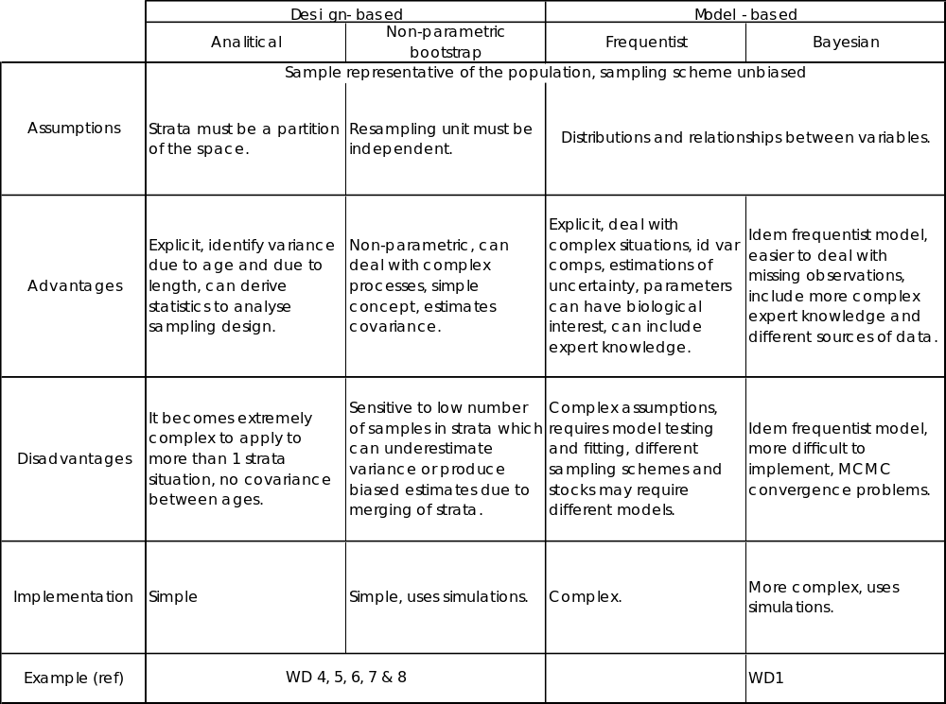
WKSCFMD 2004. Table 6.1 Comparison of methods - Summary

Conclusions
All the methods have advantages and disadvantages: the usefulness of geo-statistical methods has been demonstrated for individual analyses, Bayesian hierarchical models are technically very strong and further development of them should be promoted. But overall, the bootstrap approach was considered most appropriate for routine analysis in DATRAS. It should be technically adequate, relatively straightforward to implement and easy to explain. It will represent the calculations currently used to produce survey indices and a consistent definition of bootstrap sampling should be possible across all the surveys in the system.

The algorithm that should be implemented into DATRAS
The haul information in a survey can be split into two components: the length frequency distribution of the catch and age-length frequency distribution.
The length frequency distribution of the catch by haul will be bootstrapped by considering the hauls in an area. If, for instance, there are 5 hauls within an area, there are only 5 different length frequency distributions and any set of bootstrapped hauls within the area will contain at most 5 different distributions. We disregard the issue of sub-sampling the catch by length because most often all the catch is length-measured and, if this is not the case, the sub-samples are most often so large that this contributes very little to the variability between hauls.
In most cases, the age-length frequency distribution is collected and stored by a larger area and it is therefore not possible to bootstrap by haul. ALK will therefore be bootstrapped on an area level by considering an ALK with exactly the same length groups as the original ALK, but with bootstrapped ages within each length. If, for example, there are in total 18 fish aged within a length group, the bootstrapping draws 18 fish randomly from these, and we will get a new distribution of ages within the length considered.
Figure 7 shows the data flow when bootstrapping and the flow is described in the following section.
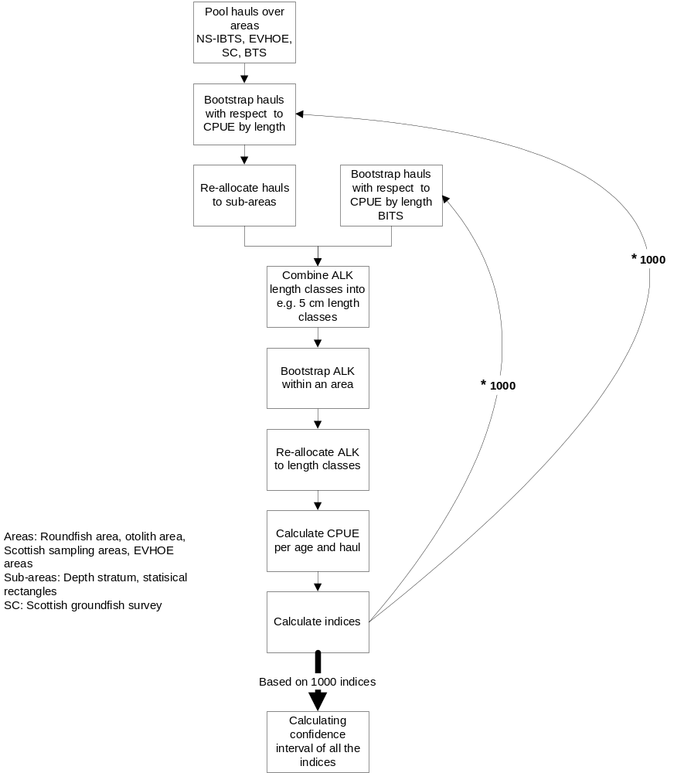
Figure 7. Data flow when bootstrapping

Length distribution bootstrapping
Sampling design regarding strata definition and number of hauls within each stratum will generally be kept when bootstrapping (Lehtonen, R. and Pahkinen, E. 2004). For those surveys where the index calculation is done by large strata with many (generally 5 to 20) hauls, the approach is straightforward. For surveys like the North Sea IBTS and BTS, which operate with rectangles as strata for index calculation, too few hauls are available within a stratum and bootstrapping will be done by RoundFish Area (RF) within the relevant standard index area for IBTS and otolith areas for the BTS. This means that only the hauls within the standard area for a given species are used in the bootstrapping, and that the standard area is subdivided by the RF (IBTS) or the otolith areas (BTS) boundaries to form the strata used in the bootstrapping (table 8). RFs and otolith areas are the strata used for ALKs on these two surveys, and because most often the ALK data is only available by RF or otolith area and because the age distribution by length is generally homogeneous within each of these areas, the ALK for the entire RF areas can still be applied.
Thus the approach can be listed as follows:

- The sample design of each survey will be followed, which means that if there are, e.g., 3 hauls in a stratum (depth strata for some surveys and rectangles for others) in a given year/quarter, the bootstrap sample will consist of 3 hauls (chosen at random with replacement) for the stratum (but for the IBTS and BTS from all hauls in the relevant RF).
- Construct the sample population
  - Pool hauls by larger areas (survey strata or RF area). The definition of “Larger” areas will be specific to survey, and in some cases also species.
  - Bootstrap hauls from this pool and put them the back into the sampling areas, i.e. for the IBTS and BTS into the relevant rectangle.
- Since all fish are usually measured, it is not necessary to bootstrap fish lengths within a haul.
Table 8. Overview of sampling strata and pooling strata
Survey | Species | Sampling strata | Pooling strata
NS-IBTS | All | Statistical rectangle | Roundfish area combined with index area
BITS | All | SubDiv + depth strata | SubDiv + depth strata
EVHOE | All | EVHOE area + depth strata | Combined depth strata of same depth within Celtic Sea or Bay of Biscay
BTS | All | Statistical rectangle | Otolith areas
Scottish groundfish survey | Mackerel | Statistical rectangle | Scottish mackerel areas
Scottish groundfish survey | Cod, whiting, haddock, monkfish | Statistical rectangle | Scottish demersal sampling areas
Scottish groundfish survey | Herring | Statistical rectangle | Scottish herring areas
Scottish groundfish survey | Sprat | Statistical rectangle | Scottish sprat areas

ALK; Bootstrap age distribution by length class
The Age-Length-Keys for all the surveys are an aggregation of individual samples from a haul combined over a larger area (Table 9). The minimum numbers of otolith from each length group which must be taken per country, survey, area and species are defined in the manuals of the different surveys and an overview is provided for each survey in section 2. For example, eight fish per length class are required for the IBTS, and at least ten fish per length class are required for the BITS by each country in the same Roundfish area/ICES subdivision.
It is assumed for most surveys that the individuals for the ALK are randomly taken from all parts of the area. Furthermore, this sampling regime for ALK data assumes that the age distribution of a length class does not significantly different within the different parts of the sampling area.
Table 9. Overview of ALK sampling areas
Survey | Area of ALK
BITS | ICES subdivision
IBTS | Roundfish area
BTS | Otolith areas
EVHOE | EVHOE areas
Scottish groundfish survey | Depend on species, see table 8

The sampled numbers of fish per length class are used as basis for bootstrapping the ALK’s.
Analyses of the data which are available in DATRAS have shown that in many cases the number of aged fish per length class is significantly lower than the required number for bootstrapping (see section 4.4).
Two options were discussed to overcome the problem. One option is to increase of the length interval from 1 cm to 2 or 5 cm. However, this increase of the length interval does not solve the problem of large individuals where aged fish are not available in all length intervals. Therefore, it is proposed to use a length plus group. All individuals which are larger than a defined length are summarized in this plus group. This length plus group will be used for the length frequency and the ALK.
The length where the plus group begins can be different from species to species, from survey and to survey, and from year to year due to different developments of the stock size and the progress of rebuilding of the stocks.
One possible way to define length class, l₊, where the plus group begins is given below. The length plus group starts when the sum of total aged fish beginning with the smallest length interval is larger than defined fraction B of the total number of aged fish. The length l₊ is defined by
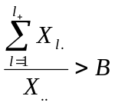.
where X_{l.} denotes the total number of aged fish in length class l, and X..represents the total number of aged fish over all length classes.
The length plus groups must be defined based on data analyses of the different surveys and after discussions with the working group which coordinates the survey.

Number of bootstraps
The length CPUE and the ALK data will be bootstrapped 1000 times as recommended by Lehtonen and Pahkinen (2004).

The index calculations.
For each of the 1000 bootstrap samples, the normal procedure for applying ALK to length data and the usual index calculations carried out.

Presentation of results.
For each index value, the entire length distribution of the bootstrap indices are given with bin size split into 20, by splitting the max – min value of the bootstrapping indices into 20 equal intervals. From this, user specified needs like CV and confidence intervals can easily be given. There are a variety of methods available to calculate confidence intervals (see for example, Efron and Tibshirani, 1993). We feel that this choice will not greatly change the relative results for different surveys or years and therefore propose that the percentile method is implemented in DATRAS. This is the simplest method available. For example, for a 90% confidence interval based on 1000 values, it involves reporting the 50th and 950th largest values.

Possible tests of the magnitude of the problem of using stratification different from that used in the index calculation for the North Sea IBTS and BTS.
The North Sea IBTS and BTS use rectangles as the basic strata in the index calculations. When bootstrapping, these strata are problematic to use because there generally are too few hauls within a stratum and RF areas (within a standard area) is then used.
If an RF areas (within a standard area) is not homogeneous in terms of expected catch (for instance coastal areas might have different mean catches than offshore areas, or there may be general trends north to south in the area), which will be the case to some extent, then the bootstrap variance estimates will overestimate the real variance because some of the 1000 simulations be sampled mainly from one corner of the RF area which the real survey will never do because it is stratified by rectangle.
In order to investigate the magnitude of the problem of using different stratification than used in the index calculation for the North Sea IBTS and BTS, several possibilities exist:
- Look at the mean catches (over many years) by rectangle for each species, age, quarter, and split RF areas into smaller units where catches seems to be more homogeneous;
- For an RF area, compare the average within-rectangle variance to the between-rectangle variance, as mentioned in Cochran (1977) eqn 5.40. If they are similar then using RF area should have little effect;
- Calculate the analytical variance with the method used by EVHOE, and compare to the bootstrap estimates;
- Do simulations in a constructed RF where there are 3D trends in mean catches and compare to no trends.
- Compare the bootstrap results with the results obtained by EVARES project.
- Use a rectangle stratification in bootstrapping for a few tests species, correct for low sample size according to Lehtonen and Pahkinen (2004) and compare to the RF bootstrapping results.
The choice of test methods will depend on resources available for the test and which test that are most cost efficient.

References
Efron, B and Tibshirani, R.J. (1993) An Introduction to the Bootstrap. CRC Press, Boca Raton.
ICES(2004) Report of the Workshop on Sampling and Calculation Methodology for Fisheries Data (WKSCMFD), 26–30 January 2004, Nantes, France. ICES CM 2004/ACFM:12
ICES(2005) Report of the Workshop on Survey Design and Data Analysis (WKSAD), 9–13 May 2005, Sète, France. ICES CM 2005/B:07.
Lehtonen, R. and E. Pahkinen. 2004."Practical Methods for design and Analysis of Complex Surveys". John Wiley & Sons Ltd. ISBN 0-470-84769-7.
ISDBITS. 2001. Improvement of Stock Assessment and Data Collection by Continuation, Standardisation and Design Improvement of the Baltic International Bottom Trawl Survey for Fishery Resource Assessment, Final Report. EU Project No. 98/099
Pennington M.R. and M.D. Grosslein, 1978. Accuracy of abundance indices based on stratified random trawl surveys. ICNAF Res. Doc. 78/IV/77 : 42 p.

- Participants

David Maxwell | CEFAS, England  david.maxwell@cefas.co.uk
Rainer Oeberst | bfa-fisch, Germany  rainer.oeberst@ior.bfa-fisch.de
Michael Pennington | IMR, Norway  michael.pennington@imr.no
Lena Larsen | ICES  lena@ices.dk
Hans Lassen | ICES  hans@ices.dk
Henrik Sparholt | ICES  henriks@ices.dk

IBTS 1. 2005, Number of hauls by statistical rectangles
RF Area | Statistical rectangle | Number of hauls
1 | 44F0 | 2
 | 44F1 | 2
 | 45F0 | 2
 | 45F1 | 2
 | 45F2 | 2
 | 45F3 | 2
 | 45F4 | 2
 | 46F0 | 2
 | 46F1 | 2
 | 46F2 | 2
 | 46F3 | 2
 | 47E8 | 2
 | 47E9 | 2
 | 47F0 | 2
 | 47F1 | 2
 | 47F2 | 2
 | 47F3 | 2
 | 48E7 | 1
 | 48E8 | 2
 | 48E9 | 2
 | 48F0 | 2
 | 48F1 | 2
 | 48F2 | 2
 | 48F3 | 2
 | 49E8 | 2
 | 49E9 | 2
 | 49F0 | 2
 | 49F1 | 2
 | 49F2 | 2
 | 49F3 | 2
 | 50E8 | 1
 | 50E9 | 2
 | 50F0 | 2
 | 50F1 | 2
 | 50F2 | 2
 | 50F3 | 1
 | 51E8 | 1
 | 51E9 | 2
 | 51F0 | 1
 | 51F1 | 1
 | 51F2 | 1
2 | 39F1 | 3
 | 39F2 | 3
 | 40F0 | 3
 | 40F1 | 3
 | 40F2 | 3
 | 40F3 | 3
 | 40F4 | 3
 | 41F0 | 3
 | 41F1 | 3
 | 41F2 | 2
 | 41F3 | 3
 | 41F4 | 3
 | 42F0 | 2
 | 42F1 | 2
 | 42F2 | 2
 | 42F3 | 2
 | 42F4 | 2
 | 43F0 | 2
 | 43F1 | 2
 | 43F2 | 2
 | 43F3 | 2
 | 43F4 | 2
 | 44F2 | 2
 | 44F3 | 2
 | 44F4 | 2
3 | 41E7 | 3
 | 41E8 | 3
 | 41E9 | 3
 | 42E7 | 2
 | 42E8 | 2
 | 42E9 | 2
 | 43E8 | 2
 | 43E9 | 2
 | 44E6 | 2
 | 44E7 | 2
 | 44E8 | 2
 | 44E9 | 3
 | 45E6 | 2
 | 45E7 | 2
 | 45E8 | 2
 | 45E9 | 2
 | 46E6 | 1
 | 46E7 | 2
 | 46E8 | 3
 | 46E9 | 2
 | 47E6 | 1
 | 47E7 | 2
4 | 36F0 | 2
 | 37F0 | 1
 | 37F1 | 2
 | 38E9 | 2
 | 38F0 | 2
 | 38F1 | 2
 | 39E8 | 2
 | 39E9 | 2
 | 39F0 | 2
 | 40E8 | 2
 | 40E9 | 2
5 | 31F1 | 2
 | 32F1 | 4
 | 33F1 | 2
 | 33F2 | 2
 | 34F1 | 2
 | 34F2 | 3
 | 35F0 | 2
 | 35F1 | 1
 | 35F2 | 3
 | 36F1 | 3
 | 36F2 | 2
6 | 31F2 | 2
 | 32F2 | 2
 | 32F3 | 3
 | 33F3 | 4
 | 33F4 | 2
 | 34F3 | 3
 | 34F4 | 2
 | 35F3 | 2
 | 35F4 | 3
 | 36F3 | 3
 | 36F4 | 2
 | 36F5 | 2
 | 36F6 | 2
 | 36F7 | 2
 | 37F2 | 3
 | 37F3 | 3
 | 37F4 | 2
 | 37F5 | 2
 | 37F6 | 2
 | 37F7 | 2
 | 37F8 | 2
 | 38F2 | 3
 | 38F3 | 3
 | 38F4 | 2
 | 38F5 | 2
 | 38F6 | 3
 | 38F7 | 2
 | 38F8 | 1
 | 39F3 | 3
 | 39F4 | 2
 | 39F5 | 2
 | 39F6 | 3
 | 39F7 | 3
 | 39F8 | 1
7 | 40F5 | 2
 | 40F6 | 2
 | 40F7 | 3
 | 41F5 | 2
 | 41F6 | 2
 | 41F7 | 3
 | 42F5 | 2
 | 42F6 | 2
 | 42F7 | 4
 | 43F5 | 2
 | 43F6 | 2
 | 43F7 | 2
 | 44F5 | 2
8 | 43F8 | 4
 | 44F8 | 5
 | 44F9 | 3
 | 44G0 | 5
 | 44G1 | 3
 | 45F9 | 2
 | 45G0 | 3
 | 45G1 | 3
 | 46G0 | 3
9 | 41G0 | 1
 | 41G1 | 2
 | 41G2 | 2
 | 42G1 | 3
 | 42G2 | 3
 | 43G0 | 1
 | 43G1 | 5
 | 43G2 | 2

IBTS q1. 2006, Number of hauls per RF area

Round fish area | Number of hauls
1 | 75
2 | 61
3 | 47
4 | 21
5 | 26
6 | 80
7 | 30
8 | 31
9 | 19

Scottish ground fish survey q1, 2006, Number of hauls per statistical rectangle

Statistical rectangle | Number of hauls
36E4 | 2
36E5 | 2
36E6 | 2
37E4 | 2
37E5 | 2
37E6 | 2
38E4 | 2
38E5 | 1
38E6 | 1
39E0 | 2
39E1 | 1
39E2 | 1
39E4 | 1
39E5 | 1
40E0 | 1
40E1 | 1
40E2 | 2
40E3 | 1
41E0 | 1
41E1 | 2
41E2 | 2
41E3 | 1
42E0 | 1
42E1 | 1
42E2 | 1
42E3 | 1
43E0 | 1
43E1 | 1
43E3 | 1
44E0 | 1
44E1 | 1
44E3 | 1
44E4 | 1
45E0 | 2
45E1 | 1
45E2 | 1
45E3 | 2
45E4 | 2
46E1 | 1
46E2 | 1
46E3 | 1
46E4 | 1
46E5 | 1
46E6 | 1
47E3 | 1
47E4 | 2
47E5 | 1
47E6 | 1
48E4 | 1
48E5 | 1

BTS q3, 2004, Number of hauls per rectangle

Otolith areas | Statistical rectangles | Number per hauls
701 | 32F1 | 2
 | 32F2 | 2
 | 32F3 | 3
 | 33F1 | 1
 | 33F2 | 3
 | 33F3 | 2
 | 33F4 | 3
 | 34F2 | 2
 | 34F3 | 3
 | 34F4 | 4
702 | 35F1 | 1
 | 35F2 | 1
 | 35F3 | 3
 | 35F4 | 4
 | 36F2 | 1
 | 36F3 | 3
 | 36F4 | 3
 | 37F2 | 1
 | 37F3 | 8
 | 38F2 | 1
703 | 36F5 | 4
 | 37F4 | 2
 | 37F5 | 3
 | 38F3 | 3
 | 38F4 | 3
 | 38F5 | 2
 | 39F4 | 3
 | 39F5 | 2
704 | 36F6 | 4
 | 36F7 | 3
 | 37F6 | 3
 | 37F7 | 4
 | 37F8 | 2
 | 38F6 | 3
 | 38F7 | 4
 | 39F6 | 3
 | 39F7 | 4
 | 39F8 | 2
705 | 40F4 | 1
 | 40F5 | 1
 | 40F6 | 1
 | 41F4 | 1
 | 41F5 | 1
 | 41F6 | 1
 | 42F3 | 1
 | 42F5 | 1
 | 42F6 | 1
 | 43F4 | 1
 | 43F5 | 1
 | 43F6 | 1
 | 43F7 | 1
706 | 35F0 | 1
 | 36F0 | 1
 | 36F1 | 1
 | 37F0 | 1
 | 37F1 | 1
 | 38F0 | 1
 | 38F1 | 1
 | 39E9 | 1
 | 39F0 | 1
 | 39F1 | 1
707 | 40E9 | 1
 | 40F0 | 1
 | 40F1 | 1
 | 41E8 | 1
 | 41E9 | 1
 | 41F0 | 1
 | 42E9 | 1
 | 42F0 | 1
 | 42F1 | 1
 | 42F2 | 1
 | 43E9 | 1
 | 43F0 | 1
 | 43F2 | 1

BTS q3, 2004, Number of hauls per Otolith area

Otolith areas | Number of hauls
701 | 25
702 | 26
703 | 22
704 | 32
705 | 13
706 | 10
707 | 13

BITS q1, 2005, Number of hauls per depth stratum

Sub-division | Depth stratum | Number of hauls
22 | 20-39 | 14
24 | 20-39 | 12
24 | 40-59 | 26
24 | 60-79 | 1
25 | 20-39 | 17
25 | 40-59 | 27
25 | 60-79 | 44
25 | 80-99 | 7
26 | 100-119 | 7
26 | 20-39 | 11
26 | 40-59 | 13
26 | 60-79 | 29
26 | 80-99 | 23
28 | 20-39 | 2
28 | 40-59 | 11
28 | 60-79 | 15
28 | 80-99 | 9
28 | 100-119 | 1

BITS q1, 2005, number of hauls per Sub-division

Sub-Div | Number of hauls
22 | 15
24 | 42
25 | 98
26 | 86
28 | 38

